**Week 3 Archaic Rome**

**Outline & Summary**

1. Earliest evidence for settlement at site of Rome between 1600 and 1200 BC (Middle Bronze Age; debatable).
2. Stable community or permanent habitation at Rome in the Late Bronze Age (1200-900 BC), or around 1000 BC: various types of evidence (pottery, bronzeworking, redesign of slope of Capitoline Hill; cremation graves in the Forum -> Phase I of Latial culture (similar graves in other places at Latium).
3. In Latium in Phase IIA (c. 900-830): both cremation and inhumation.
4. In Latium in Phase IIB (c. 830-770): cremation tomb disappears (It may still remain, but overground).
5. 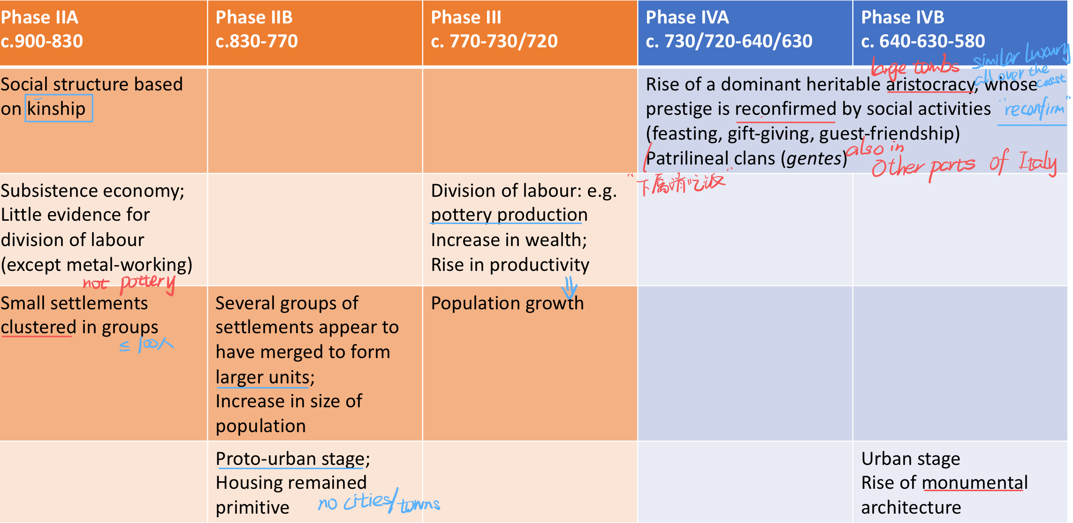Characterisation of the settlements in Latium during Early Iron Age—Phase IIA-III (c. 900-730)—orange indicating the Early Iron Age; blue the Orientalizing phase (Greek influence through colonization):

How did Rome emerge? How can the society of archaic Rome (c. 800-500) be characterized? What social, political and religious institutions operated in Rome in this period?

**Evidence and sources**

1. Archaeological evidence (contemporary, main evidence)
2. Able to shed light on aspects of Rome’s society.
3. Literary sources (much later)[1]
4. Later Roman ideas on the origin and early history of Rome.
5. (Later) Roman attitudes[2] to certain social aspects of their society.
6. linguistic evidence[3], which in combination with archaeological evidence, can lay bare elements of archaic Rome.
7. Inscriptions (contemporary, beginning around 500, the end of our period)

**Geographical position of Rome**

1. located on higher ground near a curve (弯道) and island in the lower stretches (下游) of the Tiber River.
2. The Tiber was an important north-south communication route linking the territory of the Umbri, the Sabines and the Etruscans with the Tyrrhenian Sea. Indicative of its important role is the port at the Forum Boarium (cattle market). South of the island was a location for ford the river (涉水过河)—later improved by the creation of a bridge, allegedly during the reign of Ancus Marcius (r. 640-616)[4]: Pons Sublicius.
3. Site itself: Bradley (2020, 139) emphasizes its peculiarity: rather than consisting of a defensible plateau, it was comprised of several hills. In between them ran water courses; there was a marsh (沼泽) south of the Palatine; the Velabrum contained clay (黏土) beds that were exploited for the production of pottery and tiles (砖).
4. 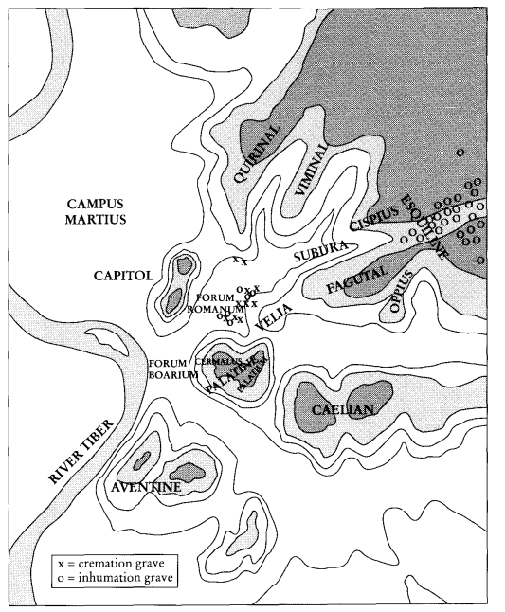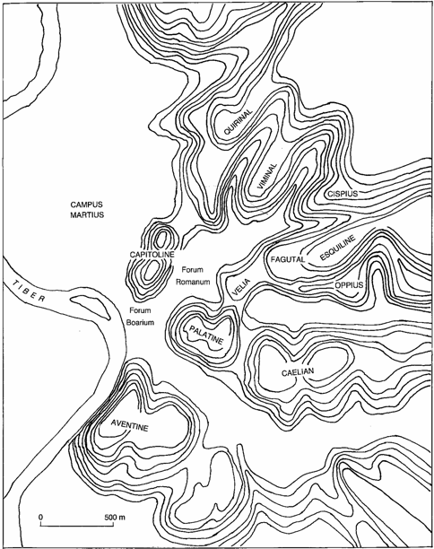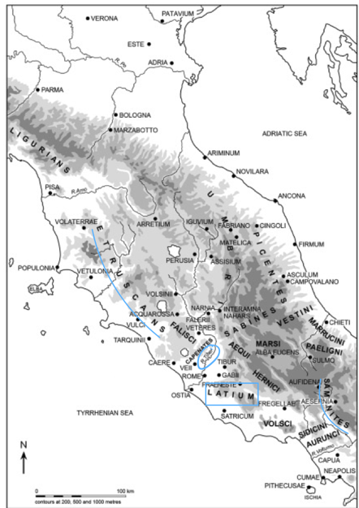Low-lying areas suffered from floods caused by the inundation (洪水) of the Tiber; a rise in the level of the Forum[5] through human intervention reduced the impact of the rise of the water levels.

Guy Bradley, *Early Rome to 290 BC: The Beginnings of the City and the Rise of the Republic* (Edinburgh 2020) xvi.

R. Ross Holloway, *The Archaeology of Early Rome and Latium* (London 1994) xi.

Guy Bradley, *Early Rome to 290 BC: The Beginnings of the City and the Rise of the Republic* (Edinburgh 2020) xvi.

**Summary**: Rome was located at a vital crossroads of routes running from the interior to the coast (via the Tiber and the Via Salaria), along the Tyrrhenian coast, and from salt pans (盐田) at the mouth of the Tiber to the Forum Boarium (Via Campana)[6].

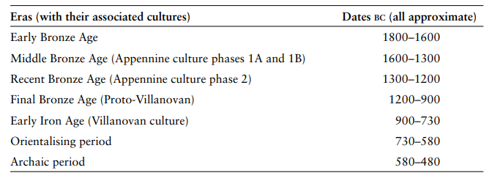**Conventional eras of Italian prehistory**

Guy Bradley, *Early Rome to 290 BC: The Beginnings of the City and the Rise of the Republic* (Edinburgh 2020) 36.

T.J. Cornell, *The Beginnings of Rome: Italy and Rome from the Bronze Age to the Punic Wars (c. 1000-264 BC)* (London 1995) 296.

**Bronze Age**

1. The earliest evidence for settlement at the site of Rome can be dated to the Middle and Recent Bronze Age, i.e., between 1600 and 1200 BC according to Bradley (2020, 141).
2. This view is not unproblematic.
3. There is debate whether this evidence testifies to continuous occupation of (some of) the hills and lower grounds at Rome or not.
4. There is debate concerning the date of the material evidence found.
5. The evidence invoked by Bradley consists of sherds of so-called Apennine pottery from the Forum Boarium and the area of the Tabularium in the Forum Romanum. Cornell (1995, 48) concedes (承认) the existence of this material, but is more sceptic (怀疑) about it indicating permanent habitation.
6. It is important to realize that Rome was not unique in having these finds: also in Ardea, Pratica di Mare (Lavinium), Ficana, Satricum, Castiglione[7] (yellow).
7. Evidence for a stable community” (Bradley 2020, 141) on the Capitoline hill in the Late Bronze Age (1200-900 BC).
8. Sherds (碎片) of pottery dating to the Middle Bronze Age; deposits of faunal and ceramic material from the Late Bronze Age.
9. Bronzeworking.
10. Remains of buildings.
11. Redesign of the slope on the Capitoline hill.
12. Fragments of Recent Bronze Age (1300-1200 BC) pottery in the Forum, which at this point might have been part of the same settlement as the one on the Capitoline; the limits of this settlement are unknown; perhaps it covered the Capitoline, the Forum and the Forum Boarium.
13. Cornell (1995, 48) dates the earliest evidence for permanent habitation in the site occupied by Rome to the period around 1000 BC. The evidence consists of cremation (火葬的) graves in the Forum. Similar graves have been found at other sites nearby in the Alban Hills, Pratica di Mare (Lavinium), perhaps Ficana, Palombara Sabina, Campo Reatino (green). It is important to emphasize this geographical diffusion in order to show that Rome was not unique in this respect.
14. 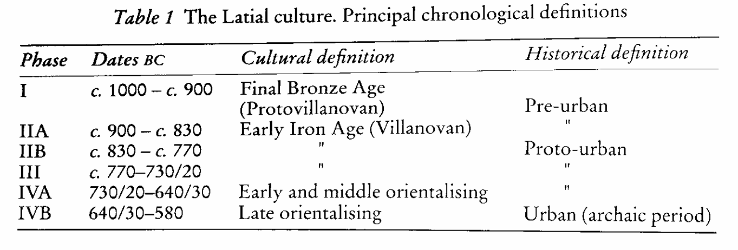The emergence of this material marks the beginning of a distinctive archaeological culture that has been termed the “Latial culture”.

T.J. Cornell, *The Beginnings of Rome: Italy and Rome from the Bronze Age to the Punic Wars (c. 1000-264 BC)* (London 1995) 50.

1. Phase I of the Latial culture, lasting from c. 1000 to c. 900 BC coincided with the last stage of the Italian Final Bronze Age (c. 1200-900 BC).

**Latial culture**

1. The term “Villanova(n) Culture” is a modern term used to refer to a culture that is characterized by cremation burial in biconical urns (双锥形瓮) which use an inverted bowl, cup or helmet as lid (盖子). The Villanovan Culture existed from c. 900 to c. 730 BC in the area of ancient Etruria, northern Latium, Tuscany, and across the Apennines into the area around Bologna and the Po plain.
2. 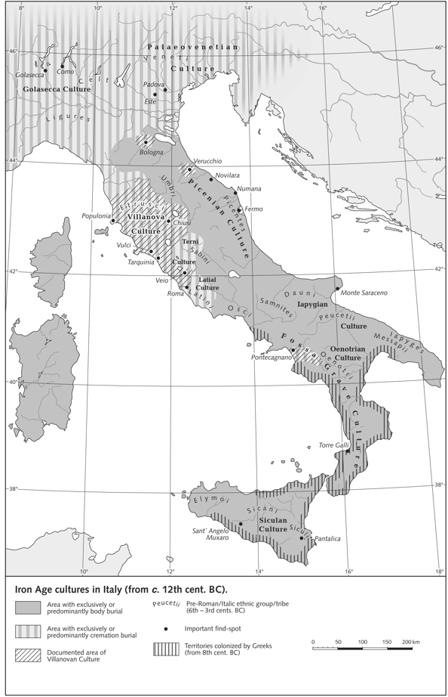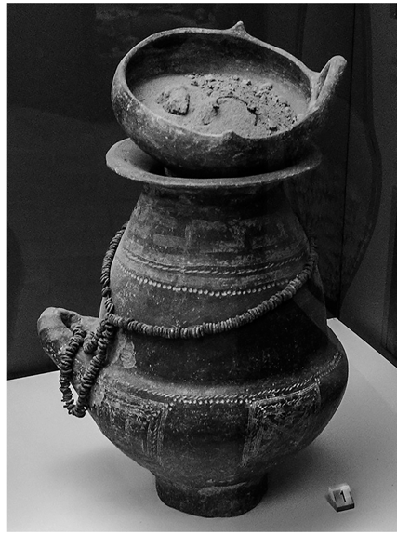Cremation tombs: early evidence for permanent habitation at the site of Rome.

Iron-age cultures in Italy. *Brill’s New Pauly, s.v. “Villanova Culture”*

Guy Bradley, *Early Rome to 290 BC: The Beginnings of the City and the Rise of the Republic* (Edinburgh 2020) xvi.

1. Chief characteristics of the burial rite in Latial culture
2. A circular jar (*dolium*, 罐) placed in a pit (坑), containing:
3. An urn (骨灰盒) with the ashes of the deceased; in phase I (c. 1000-900), the so-called hut-urn, representing a miniature house, is attested in some tombs; it becomes common in phase II (c. 900-730)
4. Pottery and bronze objects (representing daily utensils)
5. 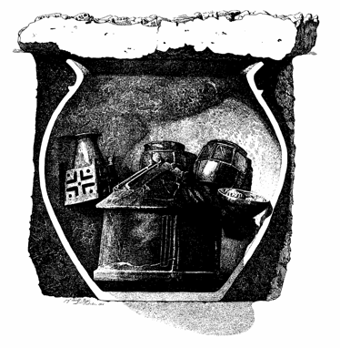Small human figure

Cremation tomb, T.J. Cornell, *The Beginnings of Rome: Italy and Rome from the Bronze Age to the Punic Wars (c. 1000-264 BC)* (London 1995) 50.

1. The graves dated to phase I can tell us little about the communities in Latium where these cremation rituals were practiced.
2. The evidence for phase II is much more abundant and prolific. For this period, graves have been attested in a number of sites in Latium: Satricum, Antium, Osteria dell’Osa, Decima, La Rustica, Laurentina (blue, above).
3. Trend in cemetery (mainly from Osteria dell’Osa)
4. Phase IIA (c. 900-830): cremation and inhumation were both performed. Cremation tombs were only used for males, and probably a privileged group of men, because inhumation was practiced in the case of both males and females. This is confirmed by the miniature objects (the grave furniture = *corredo*) interred together with the ashes.
5. What did the *corredo* consist?

* 3-4 storage containers for food/drink, cups, plates, bowls.
* Bronze items comprised brooches[8] (胸针), razor (剃刀), miniature weapons (often spear; sometimes sword).

1. How should these objects be interpreted? They should be seen as objects which were considered of need to the deceased as he passed from one life to the other, in order to exist and to perform social roles (warrior; head of household).
2. Inhumation graves were less elaborate (详尽说明) than the cremation ones; the male deceased was accompanied by only two or three pots and a brooch; the female with few vases, personal ornaments (brooch, ring, glass/amber beads) spindle whorl (纺锤轮); few female graves are more elaborate.
3. Graves at Osteria dell’Osa seem to suggest a social hierarchy and a distinction based on kinship.
4. Phase IIB (c. 830-770): the cremation tomb disappears from the archaeological record; this does not mean that cremation as a practice has disappeared; the ratio male-female with respect to the inhumation tombs for phase IIB is similar to that of phase IIA. How should this observation then be interpreted? Most likely men of a high status in the community were still cremated, but their ashes were deposited somewhere above ground.
5. Cornell (1995, 53) emphasizes that the “in every important respect the finds at Osteria dell’Osa are reproduced in all the early iron-age cemeteries of Old Latium, and the site can therefore serve as a model for the historical reconstruction of the daily life of the early Latin communities in general”, and thus possibly also for the community or communities inhabiting the site of Rome[9].
6. Settlements and tombs in Latium in the Early Iron Age (c. 900-730) and onwards
7. Characteristics
8. Social structure where distinctions were based on kinship; status of individuals within those groups depended on age, gender and social roles within the kinship groups and the community; there is no evidence for lasting economic stratification (分层).
9. Subsistence economy based on cultivation of cereals (谷类) and legumes (豆类); some stock-keeping.
10. Little evidence for the division and specialization of labour: pottery appears to be self-made; the same applies to textiles (纺织品). The sole exception is metal-working.
11. During phase IIA (c. 900-830), the settlements appear to have been small. E.g., the population of the settlement at Osteria dell’Osa seems to have amounted to c. 100 persons
12. But several villages might have been clustered in groups. In Rome settlements might have existed on the several hills surrounding the Forum: Palatine, perhaps also the Capitoline and the Quirinal.
13. Similar settlements appear to have existed at Ardea and Lavinium.
14. In Phase IIB (c. 830-770), several groups of settlements appear to have merged to form larger units, such as at Lake Castiglione, and at Rome (the area of habitation increased to include the Capitoline and the Forum; the Esquiline began to serve as cemetery (墓地)).
15. In Etruria, a similar development had occurred about a hundred years earlier with the introduction of the Villanova(n) Culture.
16. The change in settlement pattern in phase IIB was accompanied by an increase in the size of the population: older sites grew, and new sites emerged: e.g., Antemnae, Fidenae, Crustumerium, Corniculum, Tibur.
17. 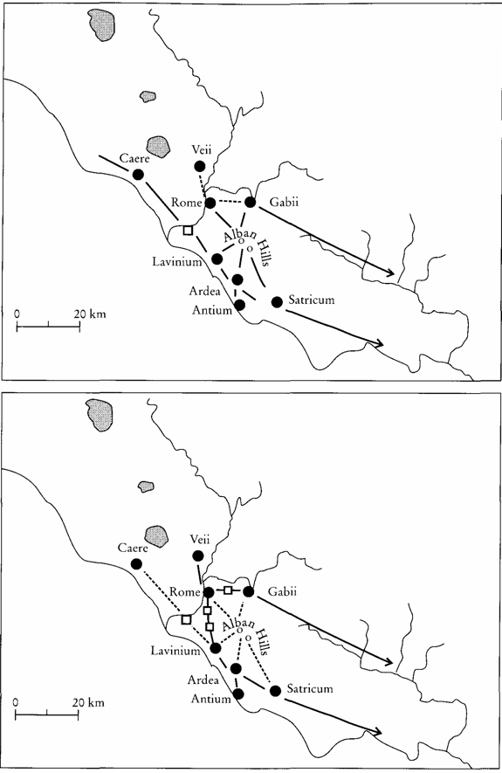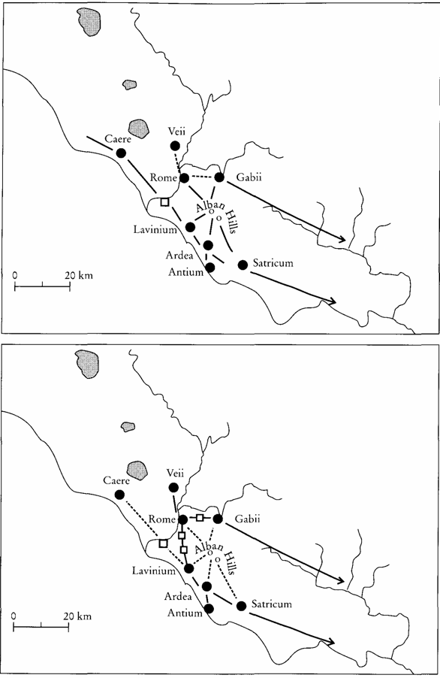The area of the Alban Hills either experienced a decrease in population or, at most, a stabilization in phase IIB; no clustering of settlements is attested here. A change in trade routes might have caused this development.

Trade routes Latium. T.J. Cornell, *The Beginnings of Rome: Italy and Rome from the Bronze Age to the Punic Wars (c. 1000-264 BC)* (London 1995) 296.

1. Phase IIB did not lead to any clear changes in social structure: they are called proto-urban.
2. Housing remained rather primitive.
3. Phase III (c. 770-730/720 BC) did not constitute a sudden break in the mode of life of the settlements in Latium. Gradual developments occurred instead:
4. Growth in population.
5. Increase in wealth as evidenced by the material found in the graves.
6. Rise in productivity (in part due to innovations in agricultural techniques).
7. Emergence of the cultivation of olives and vines.
8. During this period, pottery began to be produced as a specialized craft, replacing home-made pottery.
9. Phase IVA (730/720-640/630) and IVB (urban stage, 640/630-580) saw radical changes in the social structure of Latium:
10. 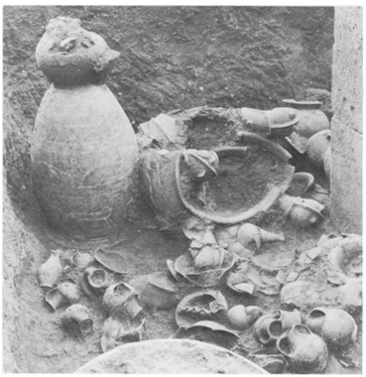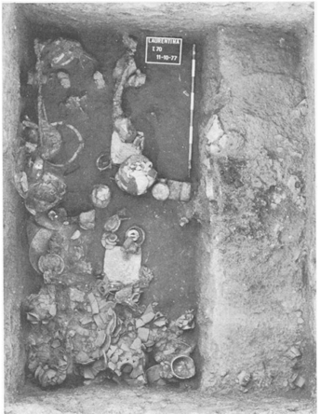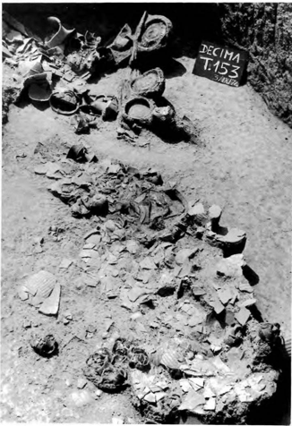Items of exceptional wealth found in some of the tombs reveal the emergence of durable social stratification, and thus the rise of a dominant heritable aristocracy[10]. The evidence comes from cemeteries, especially those at Osteria dell’Osa, La Rustica, Laurentina, the Esquiline, and the Castel di Decima (the latter of which was most important with c. 350 tombs discovered).

Tombs of the 7th century BC from Laurentina. T.J. Cornell, ‘Rome and latium Vetus, 1974-79,’ Archaeological Reports 26 (1979-1980) 71-89, at 79

Tomb 153 from Castle di Decima. R. Ross Holloway, The Aechaeology of Early Rome and Latium (London 1994) 116.

1. Elements of wealth:

* Jewellery.
* Bronze tripods (三脚架), cauldrons (大锅), armor chariots[11].
* Gold and silver vessels (器皿).
* 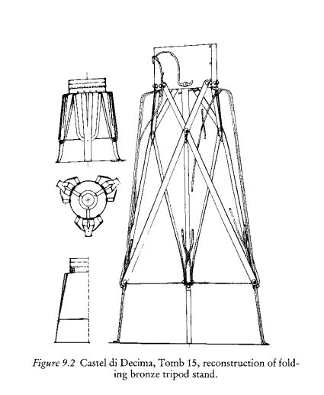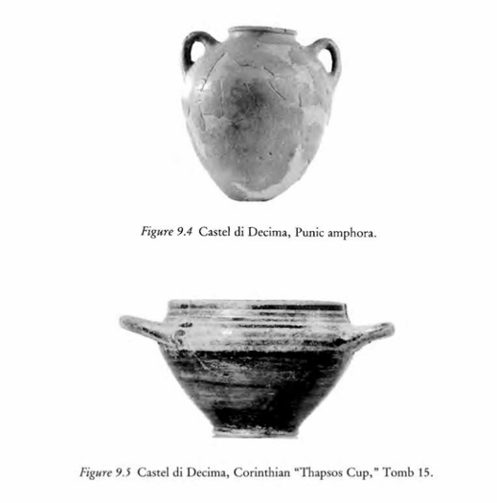Imported ceramics (陶瓷) including proto-Corinthian ware[12] (陶器), Etruscan bucchero (黑陶), Phoenician[13] amphora (双耳瓶).

R. Ross Holloway, *The Aechaeology of Early Rome and Latium* (London 1994) 118-9.

1. It needs to be emphasized that these elements of wealth could not only be found in tombs used for males, but also for females, showing that women could also enjoy a relatively high status.
2. Trend in cemetery (mainly from Castel di Decima)
3. A striking feature of the cemetery at Castel di Decima is the fact that some tombs have been grouped together. Within a given group the time that elapses (流逝) between each tomb approximates 25 years, suggesting that the memory of the deceased is continued by interring successive members in nearly the same spot.
4. This feature might be seen as a forerunner to the chamber tomb (墓室) that became common in Etruria in the 2nd half of the 7th century BC; some have also been discovered in Latium: Rome (on the Esquiline), in Osteria dell’Osa, Torrino near Laurentina; Satricum. They also feature objects showing off the wealth of the deceased and the family.
5. The chamber tomb intended to prolong the family solidarity; their existence reveals the importance of patrilineal clans (*gentes*; singular: *gens*) who were linked by their claim in having a common ancestor (real or nonreal). The existence of clans is still visible in later Roman nomenclature. The second name of a Roman male is called the *nomen gentilicium[14]* (e.g., Marcius), the first one is the *praenomen* (e.g., Marcus, always similar between generations).
6. Characteristics of the clan system

* The clan system did not only exist in Rome; it existed throughout Italy. This is shown by inscriptions which reveals a two-name system.
* Clan-system occurred across all social classes.
* In Etruria the clan-system had emerged by the early 7th century (based on epigraphic evidence; in Latium a bit later, but before 600).

1. With the most important developments in phase IV explained, we can now turn a key cultural feature of this phase—a feature which has been called ‘orientalising (东方化)’ in the field of archaeology. The evidence consists of luxury items found in so-called ‘princely tombs (王公贵族墓葬)’. They have been discovered along the Tyrrhenian coast showing similarity in contents. How can this be explained?
2. Scholars thought that the spread of this practice was due to conquering Etruscans moving into Latium and further south Campania. But this theory is not convincing.
3. The advent (到来) of orientalising luxury items is due to Greek influence[15].
4. 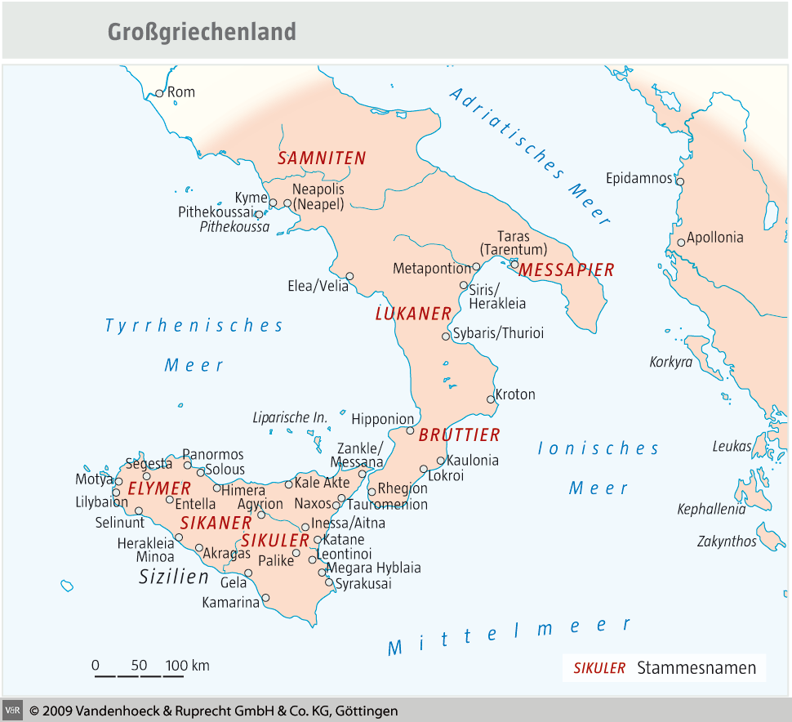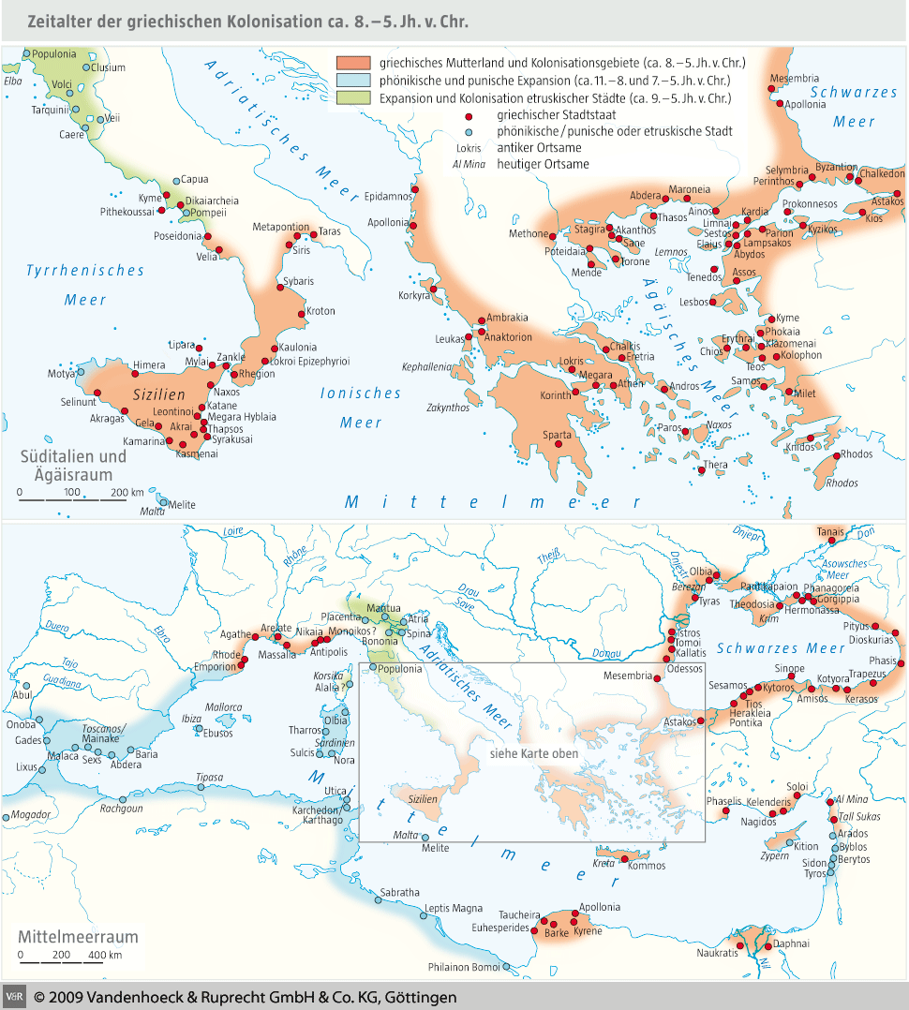The Greek influence was due the Greek colonization in southern Italy during the Archaic age. How did the colonization take shape? The earliest colony was Pithecusae (also called Aenaria), established by Euboean settlers around 770 BC. The main reason for the founding of the settlement was the quest for metals (evidence for iron-smelting and iron-working).

* A generation later, a colony was founded at Cumae (Kyme).
* Further colonies followed to the south in southern Italy and Etruria in the following two centuries. Southern Italy was called ‘Great Greece’ by the 5th century.

1. What were the effects of the Greek colonization movement?

* It had effects on structural developments during phase IV: art, architecture, religion.
* Shape of the aristocratic order: an order that gained its position to inheritance and leadership (in war especially); the prestige and honour had to be reconfirmed by social activities such as feasting, guest-friendship and gift-giving. There is evidence for such social institutions to have existed in Italy testifying to a shared aristocratic culture; the so-called ‘princely tombs’ also appear to be modelled on Greek examples.

1. Most important change that occurred in the archaic age was the formation of the city-state.
2. In the second half of the 7th century: a rise of monumental architecture and urban planning.

* The best evidence comes from Rome where around 650 the first Forum was constructed, extended around 625. There is also evidence for permanent houses from this period onwards.
* The earliest public building currently known was the Regia, probably part of a complex where the king resided.
* Around 600 the Curia Hostilia[16] was built.
* Comitium was redeveloped; a sanctuary was built to the south of it. This might be identified with the remains of a sanctuary discovered beneath black marble paving[17]. This sanctuary consisted of an altar (祭坛), a column and a block of marble with an inscription in archaic Latin. The sanctuary was called the Volcanal[18].

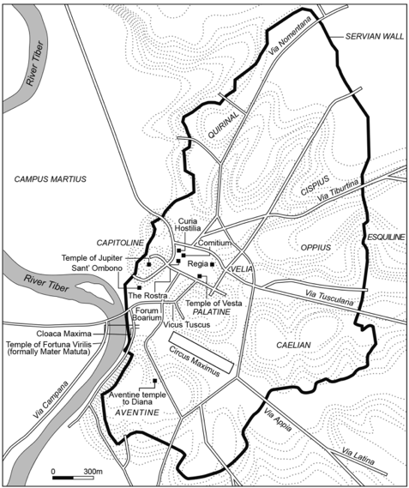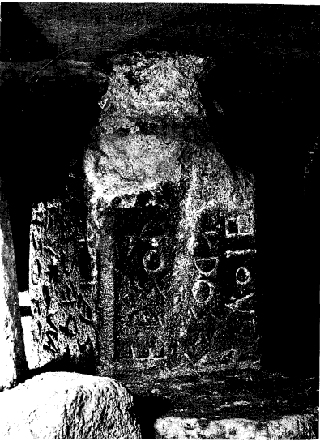

1. **Conclusion**: between the end of the 7th and the 6th centuries, Rome transformed into a city.

* Dionysius of Halicarnassus, 2.54.2:

“As the result of this expedition he celebrated a second triumph, and out of the spoils he dedicated a chariot and four in bronze to Vulcan, and near it he set up his own statue with an inscription in Greek characters setting forth his deeds.”

Myth: 753 BC.

* Votive (祭品) deposits on the Capitol and Quirinal; sanctuary in the Forum Boarium; temple on the Capitol.

1. It’s mainly in Augustus’s age, in which people realized “history”. But the textbook manly depends on it to introduce archaic Rome.
2. They’re hard to serve as direct evidence.
3. It’s also problematic. We cannot find evidence with materials already in hands. (result -> cause).
4. Many kings in that time remain uncertain.
5. It’s different from the narration of Livy.
6. Also, the island and the ford.
7. i.e., Latium.
8. It was used to get the cloths together.
9. Much of archeological evidence in Rome has been lost (destroyed, sold, used, redevelopment...).
10. This cannot be treated as evidence of kingship.
11. These things were found both in male and female tombs, thus may be a symbol of status and wealth.
12. Proto-Corinthian ware refers to pottery produced in Corinth between c. 700 and 640 BC, which often contained natural elements(?). Corinth was destroyed by Rome in 146 BC.
13. The Phoenicians were an important ancient civilization in the Mediterranean region, existing approximately from 1500 BC to 300 BC. They were primarily located along the coasts of what are now Lebanon, Syria, and Israel. Known for their maritime trade and seafaring skills, the Phoenicians developed an extensive network of merchant ships that traversed the entire Mediterranean and even reached the Atlantic Ocean. They are also renowned for developing an alphabetic writing system that was later adopted by the Greeks and Romans. Key cities such as Tyre, Sidon, and Byblos were major trade hubs during their time. The cultural and commercial activities of the Phoenicians had a significant impact on the development of the Mediterranean region.
14. Not everybody had the *nomen gentilicium*.
15. Heads of aristocratic class meet each others.
16. The senate house.
17. “REX” (“king”) was shown on it.
18. Vulcan, God of fire.